**Involuntary Power Meter Lectura System**

D.K. Karthick, N.S. Kowshik, A. Aravind, A. Kadhar mydeen

[dkkarthick555@gmail.com](mailto:dkkarthick555@gmail.com) [aathins5@gmail.com](mailto:aathins5@gmail.com) [arshaaravind12@gmail.com](mailto:arshaaravind12@gmail.com) [kadharmydeen@gmail.com](mailto:kadharmydeen@gmail.com)

K.L.N College of Engineering, Pottapalayam, Sivagangai

**ABSTRACT**

**At present electricity reading are noted by labor of TNEB which is error prone and customers are not much aware of power consumption until they pay more. In our project we proposed to develop a prepaid energy meter with Arduino micro controller to notify consumer about their usage and balance amount through internet to reduce the usage of power and also to reduce the bill amount. The prepaid energy meter described in this paper is a single phase 230V/40A energy meter which consist of a metering devise designed according to the IEC1036 (1996-09) standard and a prepaid module that uses GSM technology to communicate with the customer**.

**INTRODUCTION**

Energy meters are used to measure the amount of energy consumed by domestic, commercial and sometimes industrial users. With the growing population of energy consumers, smart meters are timely innovation which eases the energy management system. The consumers can monitor their energy consumption in real-time, recharge their accounts, monitor tariff rates and hence improves the demand response. Recharge System for prepaid

metering was presented with focus on proffering solution to human error, processing error as well as electromechanical errors while aims at proposing a system that will reduce the loss of power and revenue due to power thefts and other illegal activities.

This paper is about a proposed design of 230V/5A single phase prepaid energy meter which consist of a digital energy metering device and a microcontroller used for billing and recharging. The proposed energy meter communicates with consumer through gsm technology, every consumer is provided with a mobile application to check their usage and remaining balance. They also get notification through sms while they reach low balance (threshold value set by the consumer) and they can disconnect the heavy load which is directly connected to the relay through sms. If the user forgot to recharge and the balance comes to zero all the load will cut off and consumer has to recharge to reconnect the supply.

**EXISTING ENERGY METER TECHNOLOGIES**

1. Electromagnetic Energy Meter

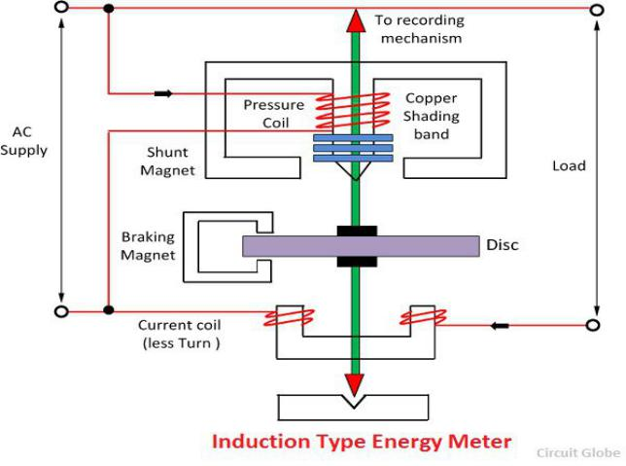

The energy meter has the aluminium disc whose rotation determines the power consumption of the load. The disc is placed between the air gap of the series and shunt electromagnet. The shunt magnet has the pressure coil, and the series magnet has the current coil.

The pressure coil creates the magnetic field because of the supply voltage, and the current coil produces it because of the current.

The field induces by the voltage coil is lagging by 90º on the magnetic field of the current coil because of which eddy current induced in the disc. The interaction of the eddy current and the magnetic field causes torque, which exerts a force on the disc. Thus, the disc starts rotating. The force on the disc is proportional to the current and voltage of the coil. The permanent magnet controls Their rotation. The permanent magnet opposes the movement of the disc and equalizes it on the power consumption.

The cyclometer counts the rotation of the disc.

The disadvantage of this type of meter is the meter may cause error due to change in temperature, waveform, frequency changes. Induction meter can use only for AC measurements. They have nonlinear scale.

2. Digital Energy meter

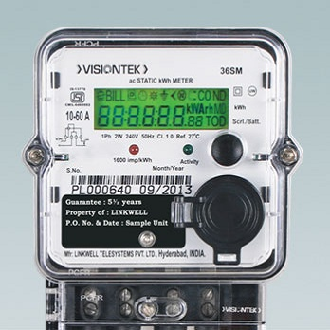

The digital energy meter works based on the following principle. All the phase voltages and currents are stepped down to the acceptable levels of energy meter chip. It process the acquired signal and performs the signal processing such as digitizing, filtering and averaging to extract active power,RMS value of current and voltage required computes the consumption of energy.The measured values are stored as bit streams in register.These registers are accessed by serial interface using

microcontroller.Micro Controller accesses the data from the chip and displays the various electrical parameters and energy consumption for the EB source with on hours on the LCD screen.

Disadvantage of Digital Meter:

Implementation of Electricity Smart meters on feeders,transformers and distribution ends,a better online system has been incorporator in the existing infrastructure of electricity

1. **Main Features Included In The Proposed Design:**

* If the recharged balance is reduced upto 50%,then a SMS is send to the user mobile through GSM module.
* If the balance is reduced to zero,then the loads will be disconnected
* Also,user can control the heavy loads through their mobile to reduce the energy consumption.
* User can monitor their energy consumption use the mobile application
* Recharge also can be done by using mobile applications

Satisfaction with smart metering continues to be high and is sustained over time - around three-quarters (74%) of respondents were satisfied with their smart meter almost a year after installation.

Prepayment customer experience is being transformed for the better with smart metering - smart prepay customers are especially likely to be satisfied with their smart meters, with 8 in 10 respondents

satisfied around a year following installation. Smart prepay respondents were also more likely to recommend smart meters, with six in ten giving the maximum score of 10 out of 10 when asked how likely they would be to recommend a smart meter to friends and family and only 5% giving a score of 4 or below. When asked about ease of topping up their meter almost 9 in 10 (88%) said topping up had become easier with a smart meter (and 86% said it had become “a lot easier”).

Consumers are using smart meters to monitor their energy consumption and to change their behaviour - almost a year following installation 80% of respondents said they still had their IHD plugged in and were using it. Additionally, more than 6 in 10 (62%) felt that having a smart meter had made a difference in some way to how they use energy in their home.

Effective guidance and support during and after installation are essential to enable consumers to realise benefits - receipt of high quality advice during the installation was routinely associated with positive outcomes, including overall satisfaction and IHD engagement, which in turn was associated with improved understanding of consumption and changes to household behaviours.